SonarCube Installation

Link: https://www.sonarsource.com/products/sonarqube/downloads/
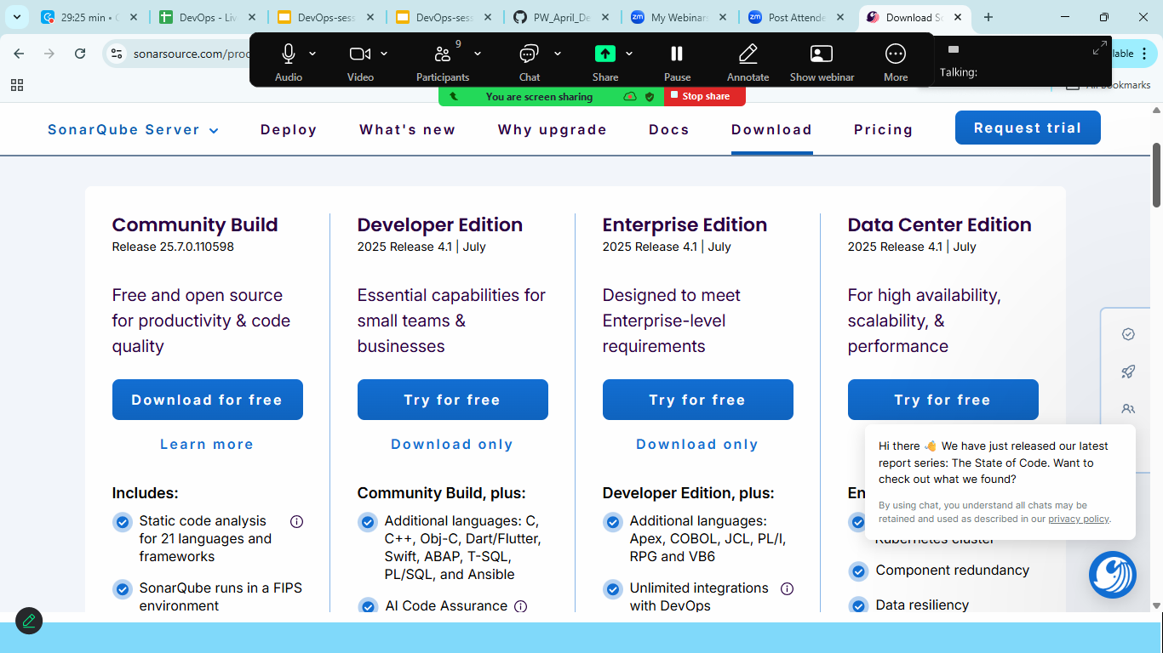
Extract to the C drive
Goto> bin>chooseyour os>double click on StartSonar

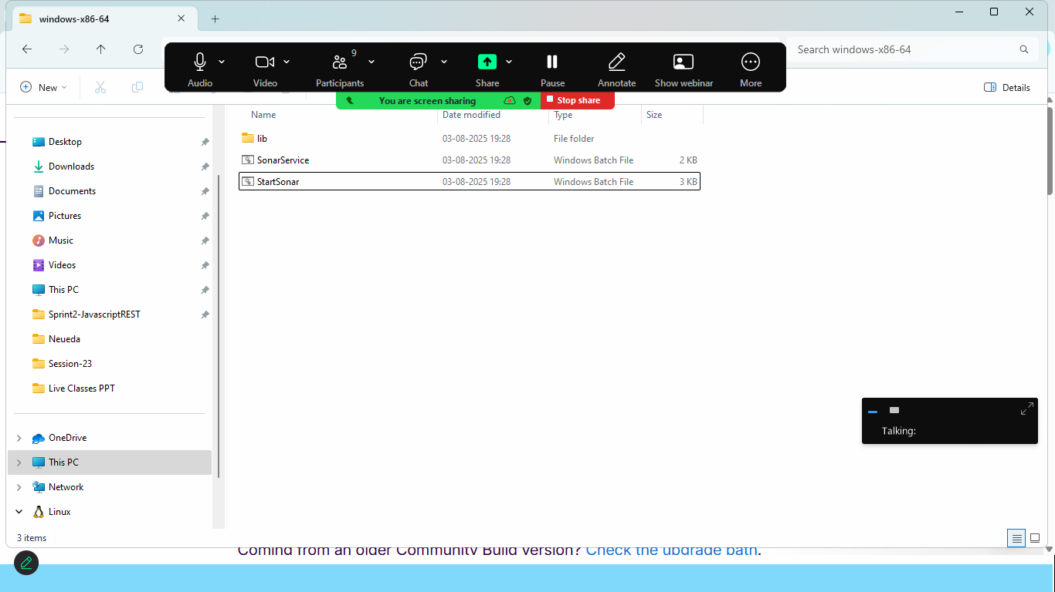
Once cmd id opened > start the sonarcube from browser> localhost:9000
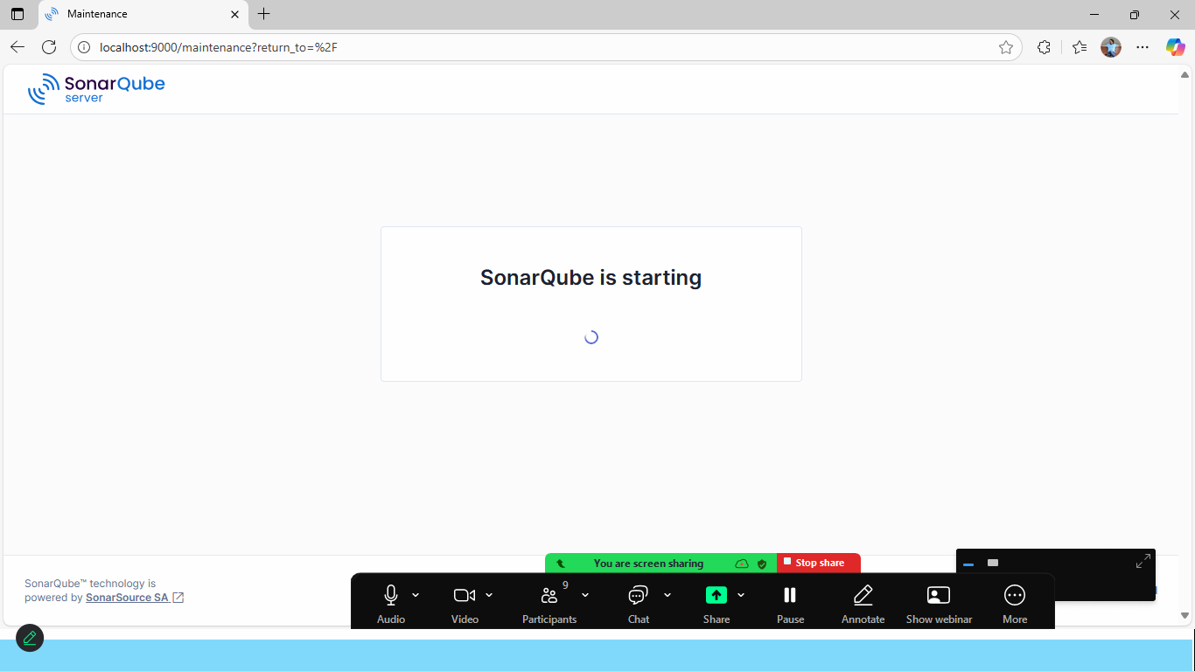
Note: Make sure Java 17 is installed in your machine if not set the path
Use Default username and password
Username: admin
Password: admin

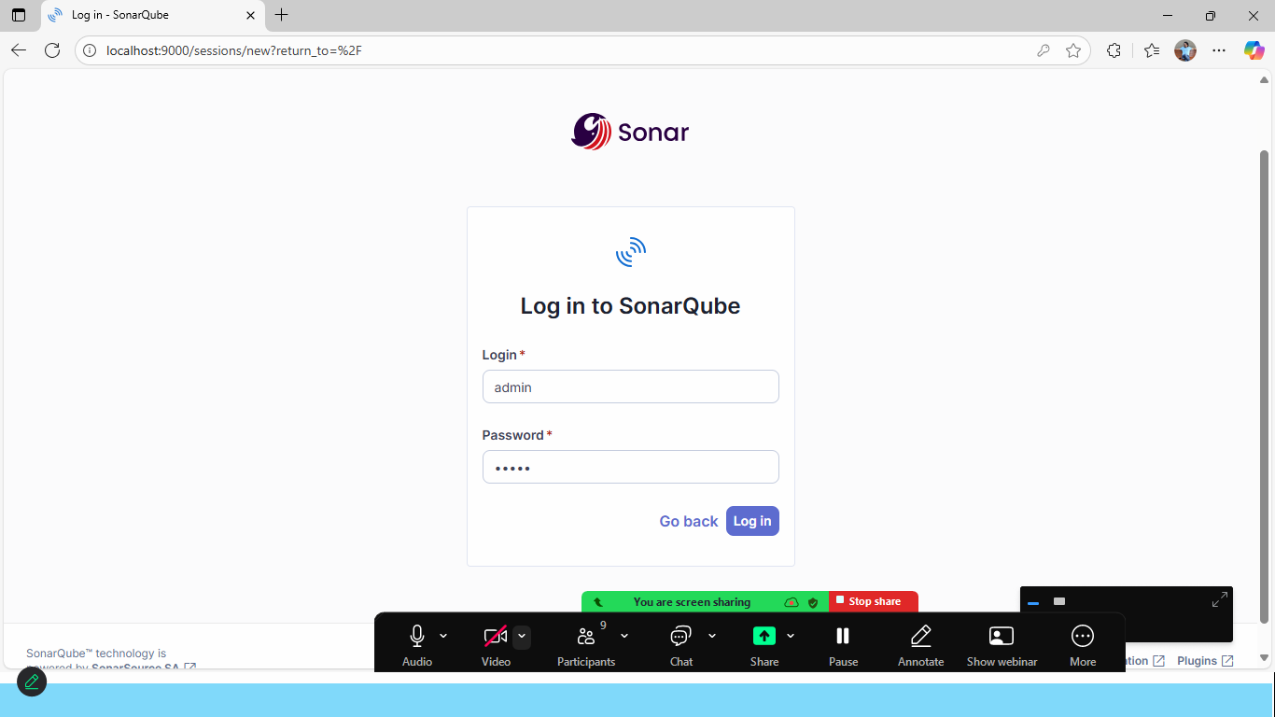

Set the New Password:
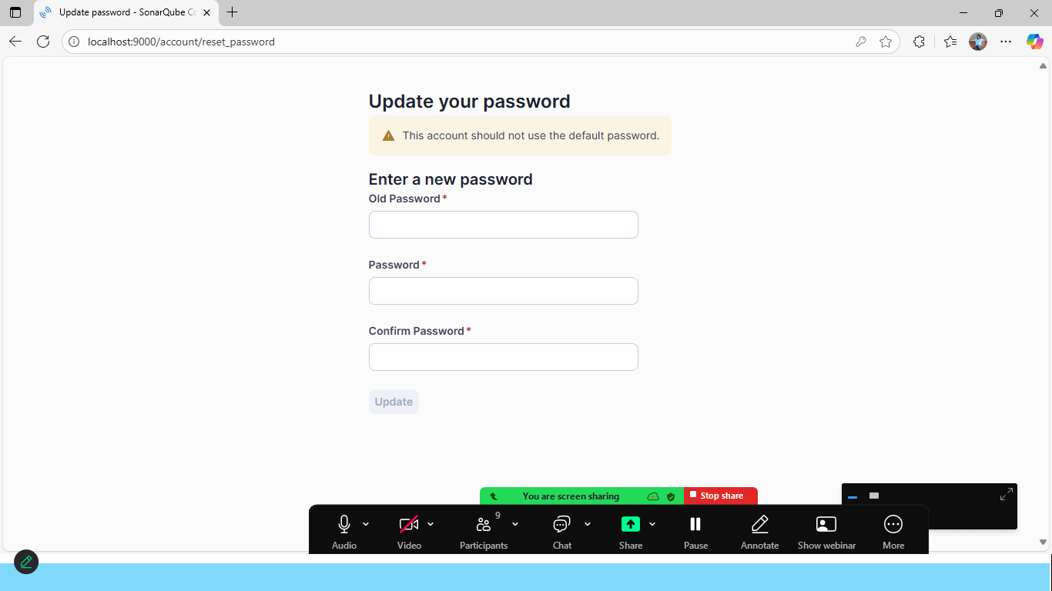

Click on Profile icon
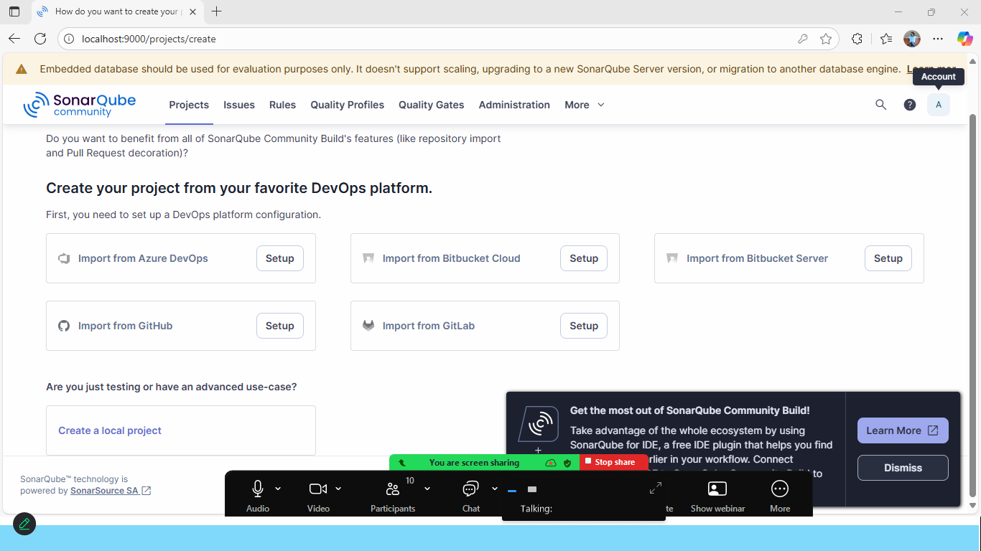
Click on profile icon> My Account
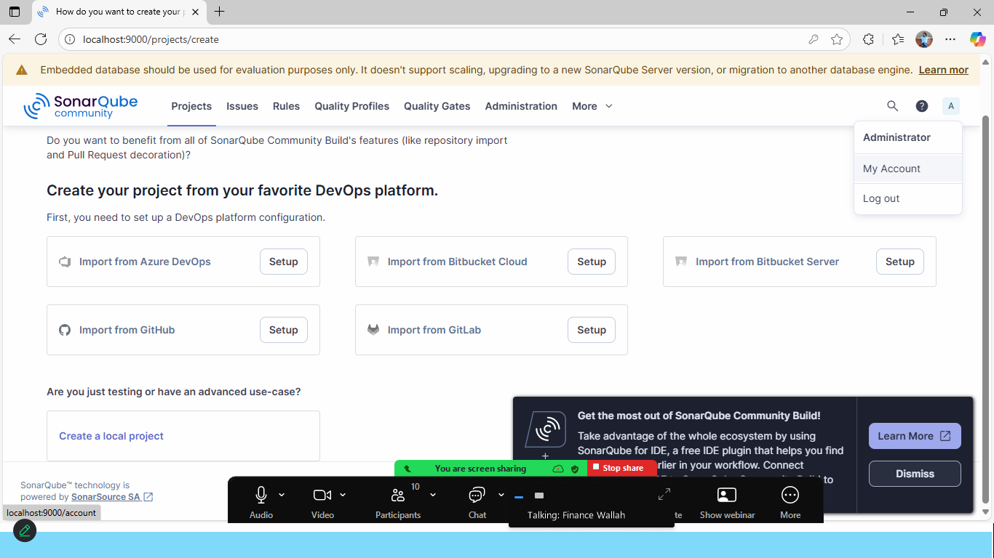

Click on Security Tab
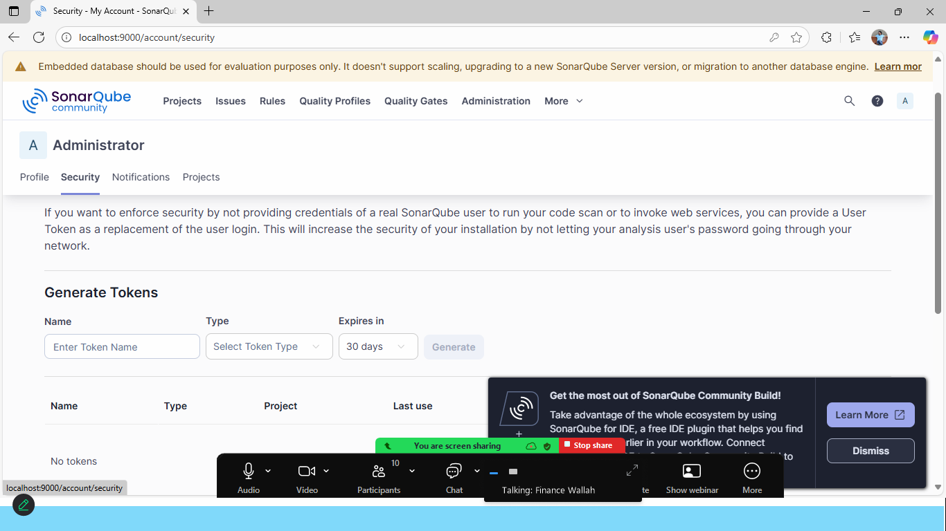
Generate Token
- Generate by Type: Global Analysis Token
